**Exercise 12: Online Bookstore – Securing RESTful Endpoints with Spring Security**

Business Scenario:

Secure your bookstore's RESTful endpoints using Spring Security with JWT-based authentication.

1. **Add Spring Security:**

* I integrated Spring Security into my project by adding spring security in pom.xml file:

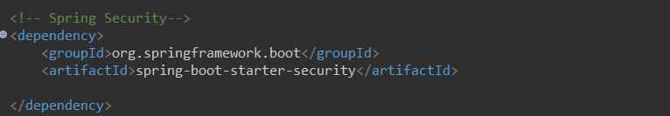

Modified Application.properties:

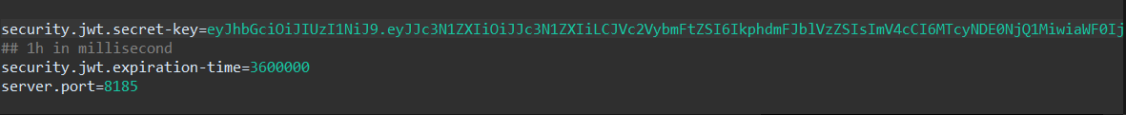

I generated the JWT secret key using Online JWT Generator where I gave the Key as “parambrata_5006856”:

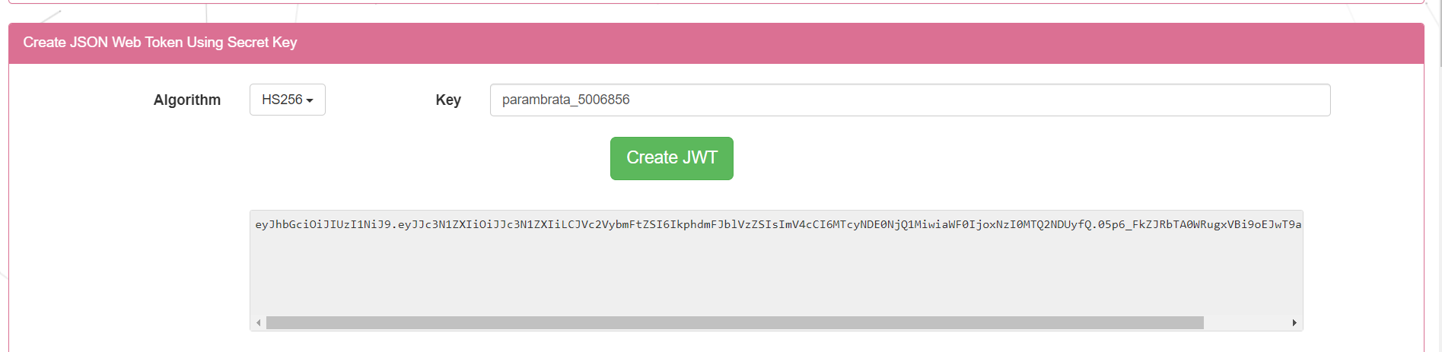

Clicking on Create JWT the secret key is generated.

1. **JWT Authentication:**

* I implemented JWT-based authentication and authorization:

Added dependency for JWT support:

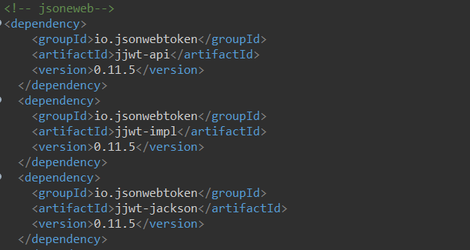

1. **CORS Handling:**

* I configured CORS to handle cross-origin requests:

The classes under “com.code.api.config” are as follows:

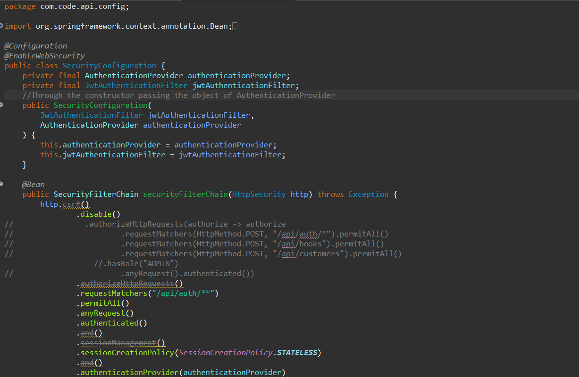

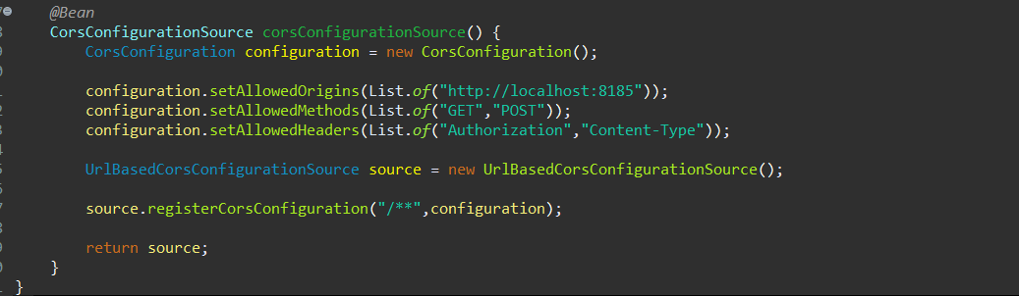

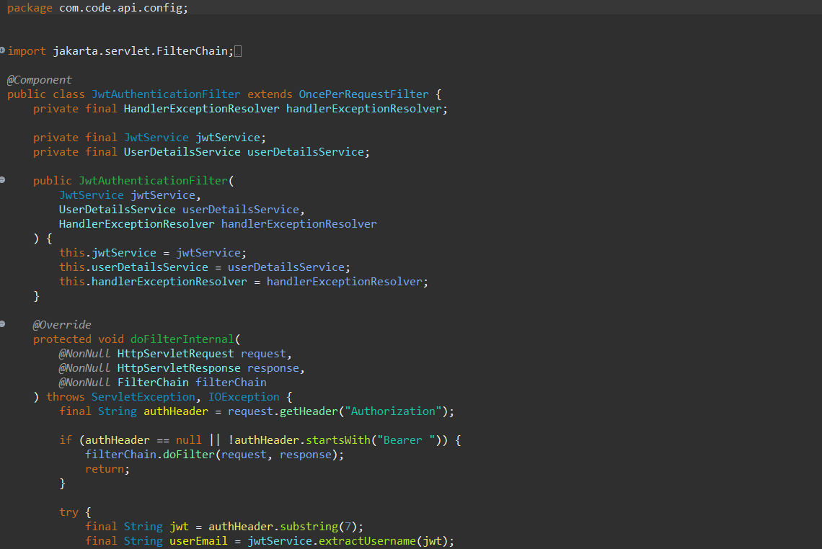

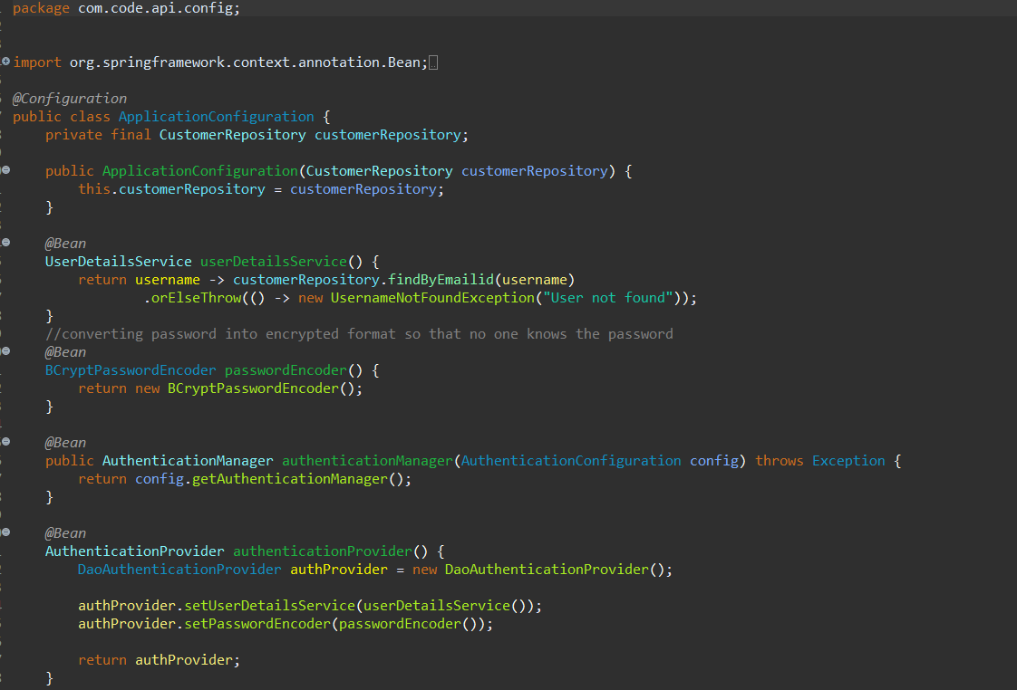

Authentication Controller and Authentication service:

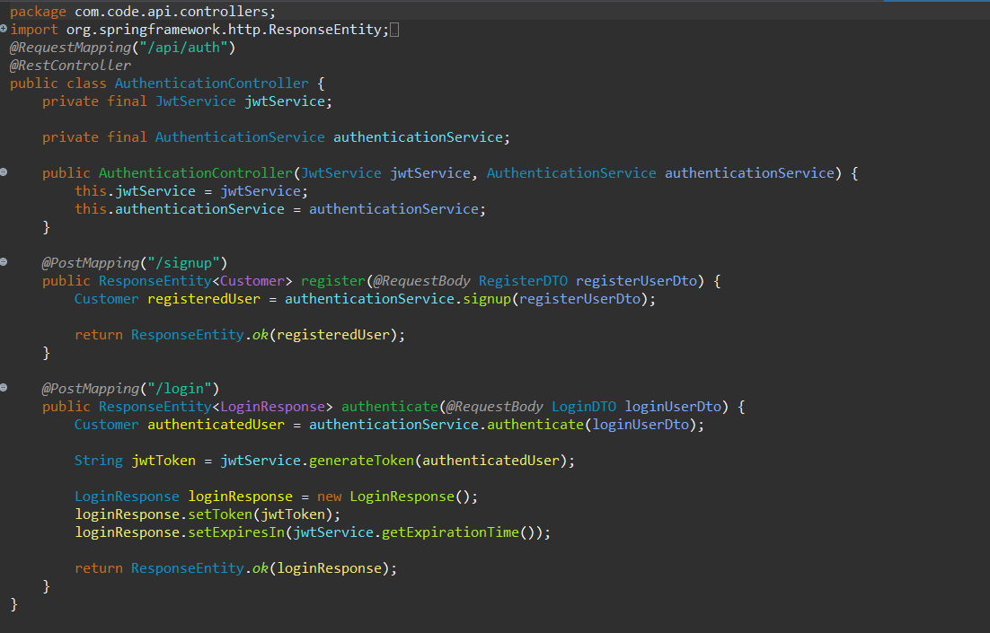

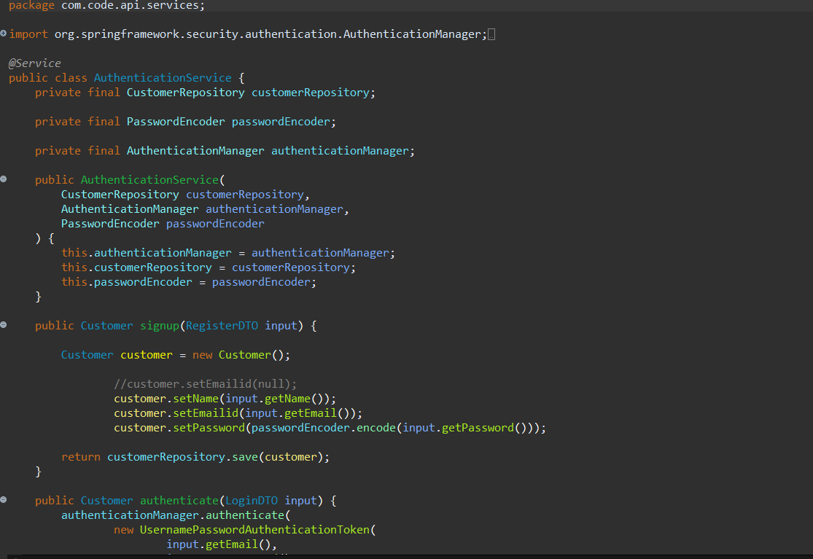

JWT Service:

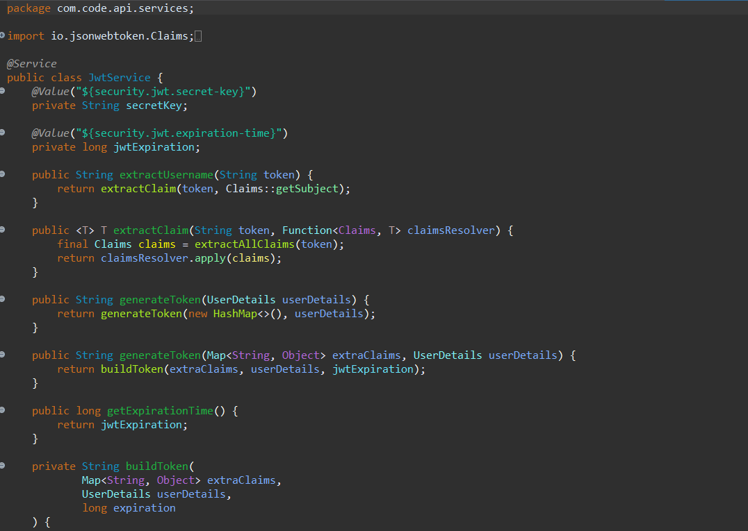

**Output:**

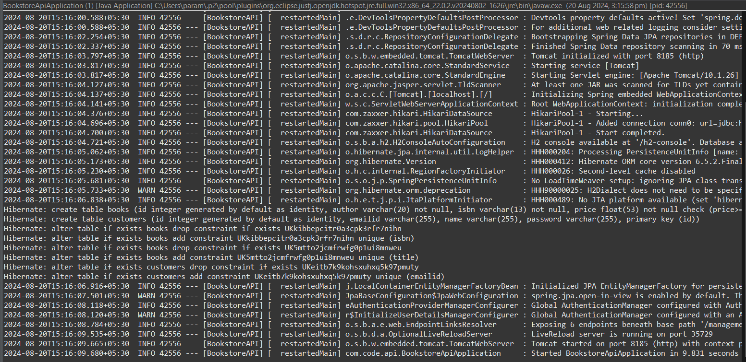

Sign-up:

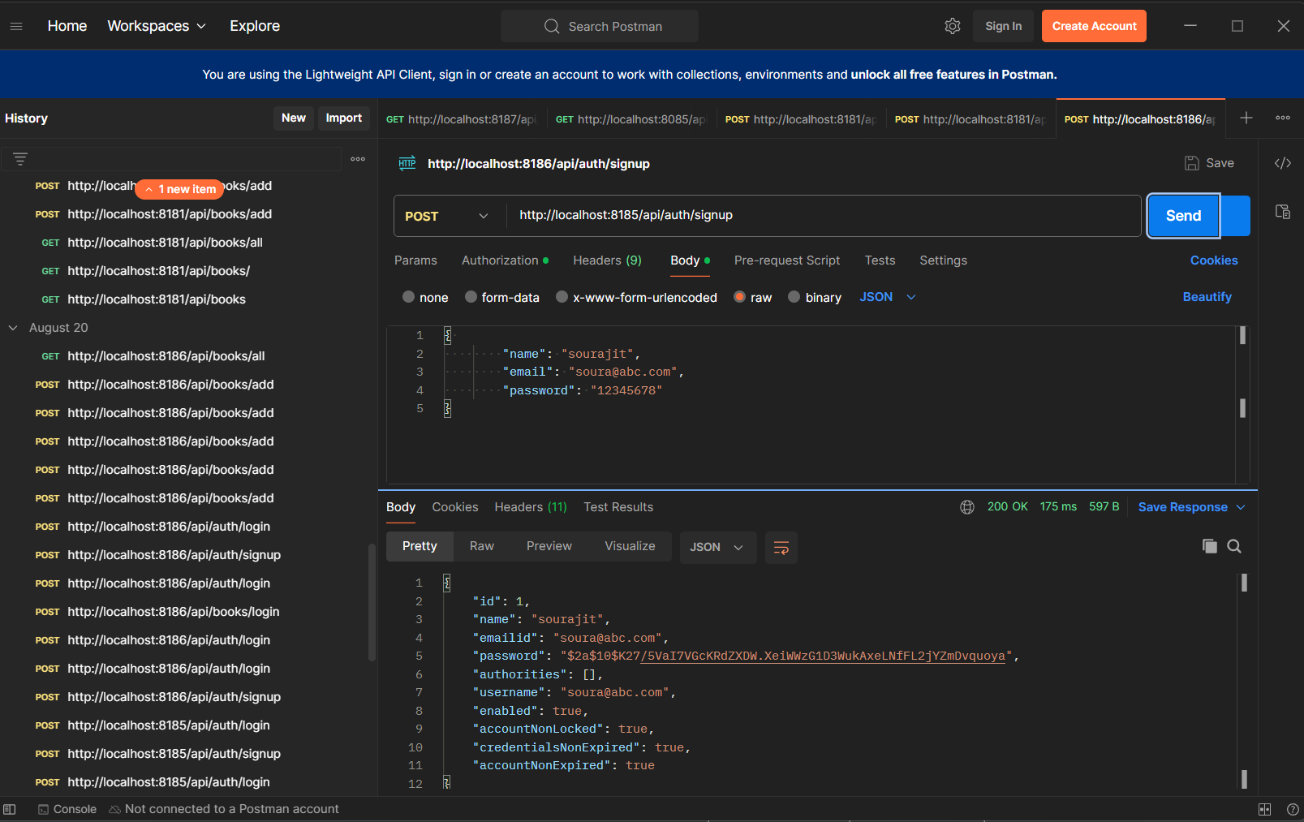

403 Forbidden:

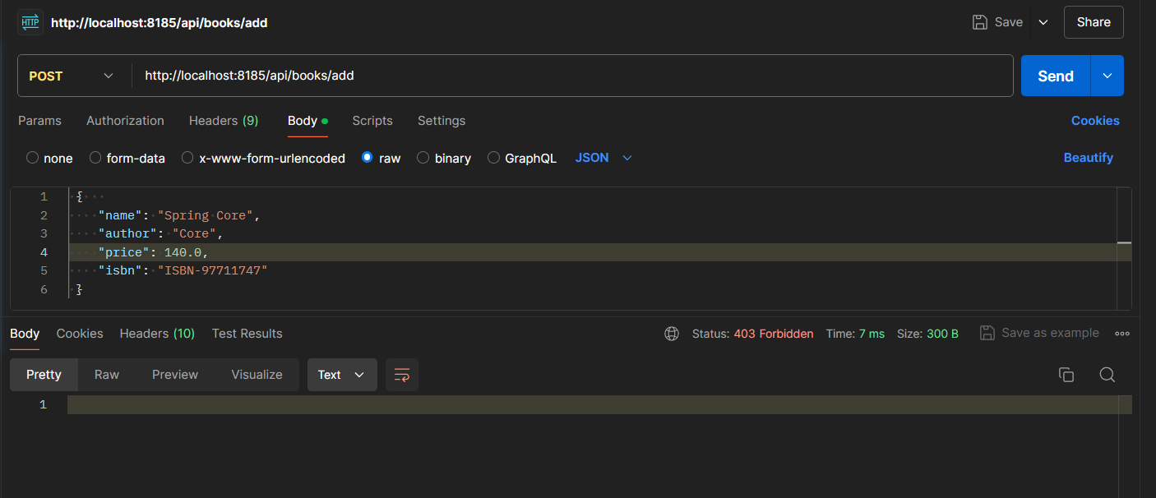

Login:

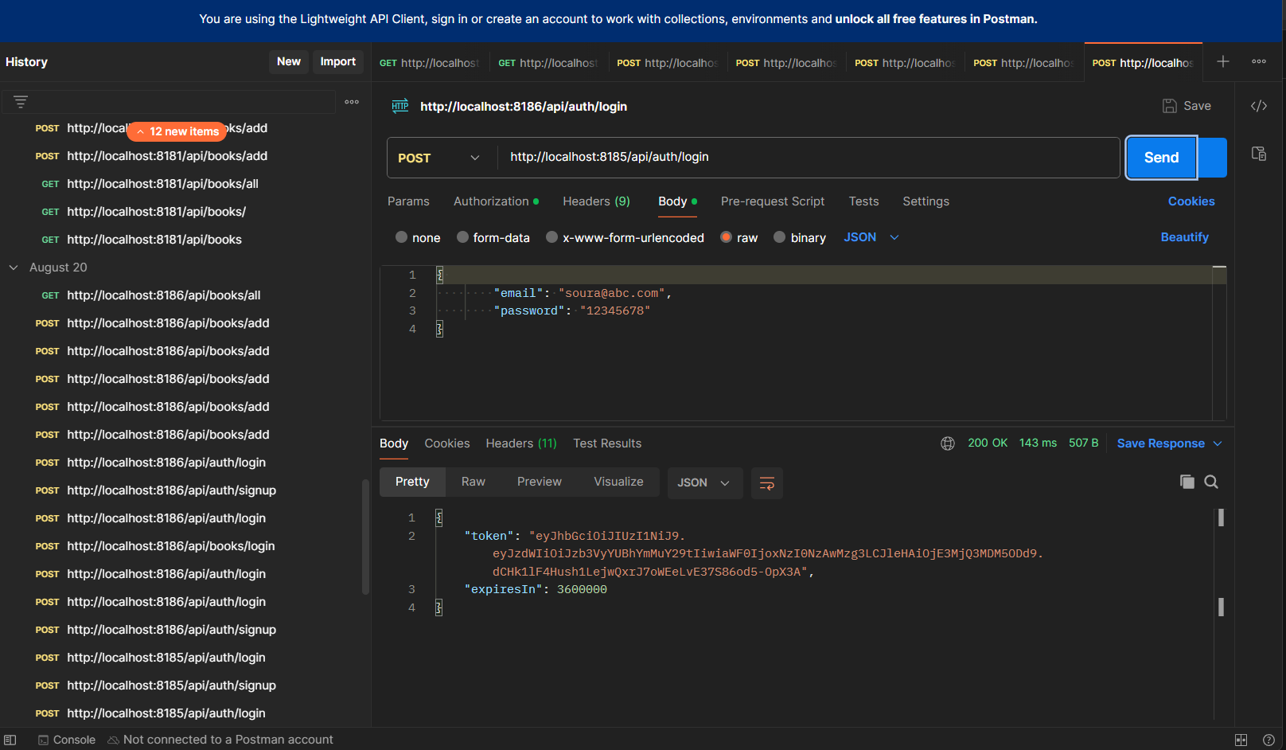

Pasting the token and after 1 hour it will automatically expire:

